**ENVIRONMENTAL CONSERVATION**

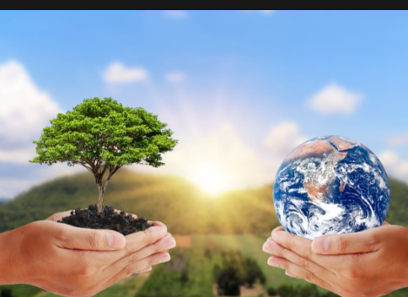

Environmental conservation refers to the practice of protecting, preserving, managing, and restoring natural environments and resources for present and future generations. It involves a range of actions and initiatives aimed at safeguarding ecosystems, air and water quality, and natural landscapes. Conservation is vital in saving and helping both animals and trees as we are all dependent on one another for survival.

METHODS OF CONSERVING THE ENVIRONMENT

1. Protect natural resources

Conservation aims to sustainably manage natural resources such as forests, freshwater sources, oceans, and minerals to ensure their availability for current and future generations. This may involve practices like sustainable forestry, responsible fishing, and water conservation measures.

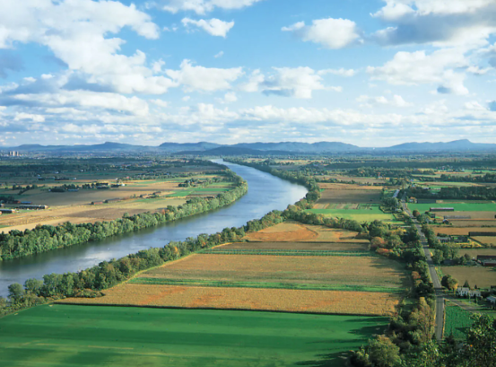

1. Mitigate pollution

Environmental conservation involves reducing pollution and minimizing the release of harmful substances into the air, water, and soil. This includes implementing regulations, adopting clean technologies, and promoting waste reduction and recycling.

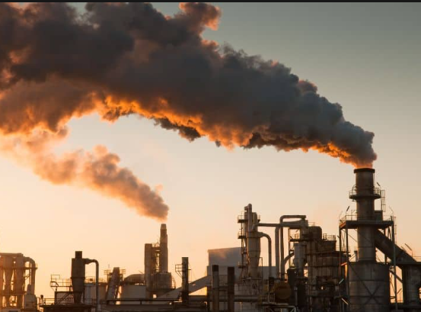

1. Environmental education and awareness

Conservation initiatives aim to raise public awareness about environmental issues and foster a sense of stewardship and responsibility for the natural world. This includes educational programs, outreach campaigns, and community engagement activities.

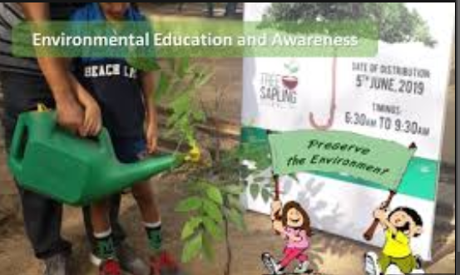

1. Protecting biodiversity

Conservation efforts focus on safeguarding the variety and abundance of plant and animal species, as well as their habitats. This includes establishing protected areas such as national parks, wildlife reserves

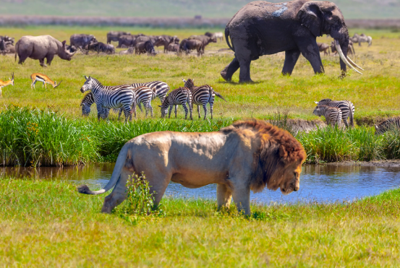

1. Suitable resource management

Conservation practices promote the responsible use of natural resources, such as water, forests, fisheries, and minerals, to ensure their availability for future generations while minimizing negative impacts on ecosystems



1. Climate change mitigation

efforts address the impacts of climate change by reducing greenhouse gas emissions, enhancing carbon sequestration through reforestation and afforestation, and implementing adaptation measures to protect vulnerable communities and ecosystems.

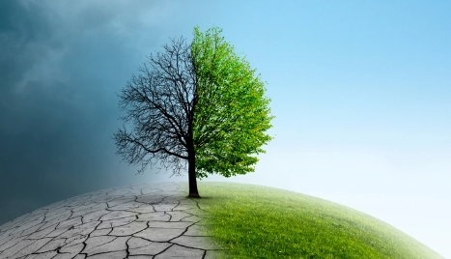

**Importance of environment conservation**

1. Environmental Protection Helps You Safeguard The Ecosystem
2. Forests Are A Significant Source Of Raw Materials
3. Protecting Environment will lead to a safe future
4. Protecting the environment leads to economic stability
5. Protecting the environment leads to better health